LiveText Student Key Code Account Set-Up
The video links below will assist you with setting up your student LiveText account at www.livetext.com. You will need to have your student LiveText account code to set up an account. You can obtain the account from your Program Director.
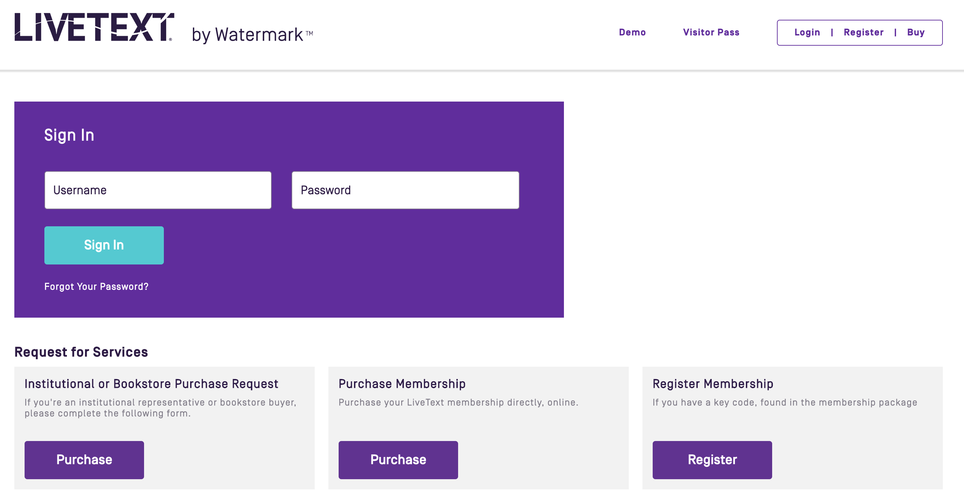
1. LiveText Account Registration:
Click Register

2. LiveText Getting Started Student Dashboard Tutorial: http://screencast-o-matic.com/watch/cDVr2KhH1a

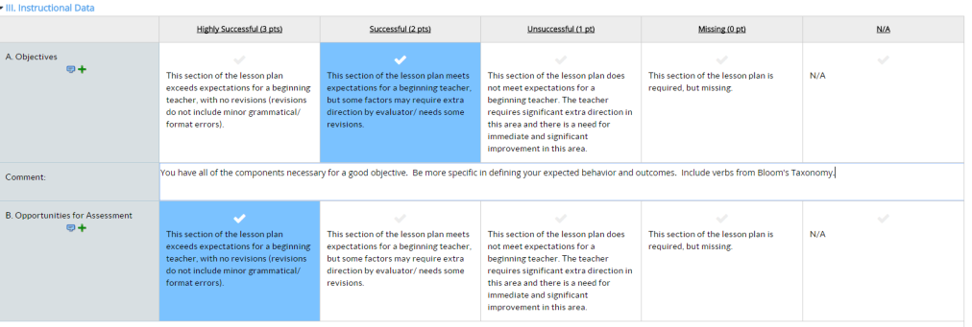
3. LiveText Student Assignment Submissions: http://screencast-o-matic.com/watch/cDVr2lhHh6 (Start-up video images have been updated.)

4. Student Help video, print & FAQ Resources: Can be found by clicking on the drop-down menu to the right of your name and then clicking on the Help link followed be the Student tab.

