Medaille College
Department of Education
BSED Early Childhood/Childhood
Professional Handbook
2021-2022

Table of Contents
Message from the Department Chair 4
Mission Statement of Medaille College 4
Mission of the Department of Education at Medaille College 4
Philosophy of the Department of Education at Medaille College 5
Department of Education Claims 5
Council for Accreditation of Education Preparation (CAEP) 6
InTASC Principles 6
Important Education Links 8
International Society for Technology in Education 8
https://www.iste.org/ 8
Ontario Ministry of Education 8
Ontario College of Teachers 8
Contact Information for the Medaille Campus 9
Contact Information for Education Faculty and Staff 9
Office of Student Teaching and Certification (OSTC) Contact Information 10
Department of Education Faculty 10
Education Course Requirements for BSED Programs 12
Catalogs 12
E-Mail 12
Attendance Error! Bookmark not defined.
Statement on Disabilities 14
Academic Integrity 14
Title IX 14
The Family Educational Rights and Privacy Act of 1974 (FERPA) 14
Campus Emergency Information and Sign up for Immediate Alert 15
Drop/Add/Withdrawal 15
Break in Enrollment 15
Academic and Professional Standards 16
Undergraduate Grading Scale 16
Credit Pending (CP) 16
Incomplete (I) 16
Methods Courses 17
Concentration Courses 17
Academic Progress Reports 17
Grade Appeal Process 17
Academic Standards 17
Department of Education Undergraduate Dismissal Policy 17
Statement on Teacher Candidate Professional Dispositions 18
Student Teaching and Certification Requirements 21
Child Abuse and SAVE Legislation Requirements for Initial Certification 21
Dignity for All Students Act (DASA) 22
Fingerprinting 22
Field Experiences (Pre-Student Teaching) 22
Student Teaching 23
Student Teacher Placement Cancellation 24
Recommendation for New York State Teaching Certification 24
New York State Certification Exams 24
Graduation 24
Appendix A 25
Teacher Candidate Professional Dispositions Support System Process 25
Appendix B 27
Child Abuse and SAVE Legislation 27

Message from the Department Chair

Hello and welcome to the Medaille College Department of Education for 2020-2021! We have had a VERY busy summer and we are all very excited to get started! Whether we are on campus, on-line virtually, synchronous or asynchronous, our entire faculty and staff are here to support you and mentor you as you move through your programs. Our collective goal is to prepare you to be fantastic teachers and to encourage you along the way through the myriad of challenges, procedures, and requirements!

If you have any questions, do not hesitate to reach out to our faculty, (including your Program Directors and Chair), or staff with any questions or concerns.

We are strongest when we work together, and I can’t wait to work with each of you.
Have a great year!

Doc Faunce

Chair, Department of Education
JFaunce@Medaille.edu
716 880-2813
DocFaunce.net

Medaille College

Medaille College traces its roots to 1875 when it was founded by the Sisters of St. Joseph as an Institute to prepare teachers among the religious community for Catholic schools. The tradition of providing an emphasis on training teachers has been with us since the beginning. In 1937, the Institute received an absolute charter from New York State and was named Mount St. Joseph Teachers College and was chartered to grant baccalaureate degrees in Education. In 1968, the Sisters of St. Joseph, led by Alice Huber, SSJ, Ph.D., initiated a change in the charter, which would create a new college, accessible to all men and women. New York State granted this charter and Medaille College was born.

Mission Statement of Medaille College

The mission of Medaille College is to educate and develop empowered individuals for academic achievement, career success and civic engagement, thereby contributing to a healthy, diverse democracy.

Mission of the Department of Education at Medaille College
The Department of Education focuses on excellence in teaching with an emphasis on personal attention to our diverse learners. Our career-oriented curriculum builds upon a liberal arts and sciences foundation as we guide students toward initial and professional certification. This program is flexible because of the multiple delivery systems available to traditional students and practicing professionals. The staff and faculty are dedicated and committed to graduating students who are effective teachers. As reflective practitioners and scholars guided by constructivist approaches (Vygotsky, 1978) to learning and teaching, we challenge our students and ourselves to reach high standards of achievement through the relentless pursuit of best teaching practices.
Learning occurs in our classrooms within a caring environment, with dedicated faculty who advise, mentor, and guide students from their admission to the program through to the completion of their capstone courses. Ultimately, we are invested in learning, teaching, and the continued success of our students.

Philosophy of the Department of Education at Medaille College
Medaille College’s Department of Education focuses on excellence in teaching with an emphasis on personal attention to our diverse student body. The faculty consists of scholar practitioners focused on research-based best practice and dedicated to graduating men and women who will positively impact P-12 students. Our education programs provide a solid foundation in the study, design, and implementation of planning, instructing and assessing in the classrooms of the twenty-first century.
The Department of Education subscribes to the overarching philosophy of constructivism (Vygotsky, 1978), a unifying thread that is evident in all of our education programs. At the root of constructivism is the belief that knowledge does not exist independent of the learner. Instead, constructivism presents a student-centered model in which students make meaning for themselves by building on prior knowledge. The teacher contributes more as a facilitator, designing culturally relevant instruction for students in order for them to develop further mental paradigms.
Bridging theory and practice, our teacher candidates experience learning in the classroom and through field experiences. A background in issues of educational philosophy and history, an examination of contemporary topics affecting curriculum and instruction within schools, and the exploration of diversity considerations in our culture and society provide a solid foundation from which students can analyze their experiences in real-world classrooms. Additionally, courses focusing on pedagogy and the planning, instructing, and assessing cycle of learning allow teacher candidates to hone the skills they will use from their first day as a teacher. Concurrent to this coursework, faculty and staff coach teacher candidates in developing the metacognitive strategies and reflective skills necessary to monitor and direct their own performance, learning, and future teaching.

Department of Education Claims
A process was established to systematically collect data that addresses the DOE’s three primary claims to the Teacher Education Accreditation Council (TEAC). Medaille College graduates are qualified and competent as demonstrated by the following claims.
Claim 1: Medaille College graduates know the subject matter in their certification area(s).
Claim 2: Medaille College graduates meet the needs of diverse learners through effective pedagogy and best teaching practices.
Claim 3: Medaille College graduates are caring educators.

Medaille Teacher Education Programs have TEAC Accreditation effective until April 29, 2022

Association for Advancing Quality in Teacher Preparation (AAQEP)

Medaille Teacher Education Programs have TEAC Accreditation effective until April 29, 2022.

Association for Advancing Quality in Educator Preparation (AAQEP)

AAQEP promotes the preparation of effective educators in innovative, outcome-focused programs that engage education’s toughest challenges directly and in context. AAQEP’s comprehensive standards specify aspects of completer performance and program practice that distinguish effective programs. Its system leverages collaboration in quality assurance to foster improvement and support innovation. A process has been established to systematically collect data that address AAQEP standards, which serve as the basis for accreditor’s review.

Standard 1: Candidate/Completer Performance
Program completers perform as professional educators with the capacity to support success for all students.

Standard 2: Completer Professional Competence and Growth
Program completers adapt to working in a variety of contexts and grow as professionals.

Standard 3: Quality Program Practices
The program has the capacity to ensure that its completers meet Standards 1 and 2.

Standard 4: Program Engagement in System Improvement
Program practices strengthen the P-20 education system in light of local needs and in keeping with the program's mission.

InTASC Principles

Standard #1: Learner Development
The teacher understands how learners grow and develop, recognizing that patterns of learning and development vary individually iwthin and across the cognitive, linguistic, social, emotional, and physical areas, and designs and implements developmentally appropriate and challenging learning experiences.

Standard #2: Learning Differences
The teacher uses understanding of individual differences and diverse cultures and communities to ensure inclusive learning environments that enable each learner to meet high standards.

Standard #3: Learning Environments
The teacher works with others to create environments that support individual and collaborative learning, and that encourage positive social interaction, active engagement in learning, and self-motivation.

Standard #4: Content Knowledge
The teacher understands the central concepts, tools of inquiry, and structures of the discipline(s) he or she teaches and creates learning experiences that make these aspects of the discipline accessible and meaningful for learners to assure mastery of the content.

Standard #5: Application of Content
The teacher understands how to connect concepts and use differing perspectives to engage learners in critical thinking, creativity, and collaborative problem solving related to authentic local and global issues.

Standard #6: Assessment
The teacher understands and uses multiple methods of assessment to engage learners in their own growth, to monitor learner progress, and to guide the teacher’s and learner’s decision making.

Standard #7: Planning for Instruction
The teacher plans instruction that supports every student in meeting rigorous learning goals by drawing upon knowledge of content areas, curriculum, cross-disciplinary skills, and pedagogy, as well as knowledge of learners and the community context.

Standard #8: Instructional Strategies
The teacher understands and uses a variety of instructional strategies to encourage learners to develop deep understanding of content areas and their connections, and to build skills to apply knowledge in meaningful ways.

Standard #9: Professional Learning and Ethical Practice
The teacher engages in ongoing professional learning and uses evidence to continually evaluate his/her practice, particularly the effects of his/her choices and actions on others (learners, families, other professionals, and the community), and adapts practice to meet the needs of each learner.

Standard #10: Leadership and Collaboration
The teacher seeks appropriate leadership roles and opportunities to take responsibility for student learning, to collaborate with learners, families, colleagues, and other school professionals, and community members to ensure learner growth, and to advance the profession.

Important Education Links

NYS Education Department (NYSED)
http://www.nysed.gov
NYS Teacher Certification Exams (NYSTCE)
www.nystce.nesinc.com
EngageNY
https://www.engageny.org
NYS Learning Standards
http://www.p12.nysed.gov/ciai/standards.html
NYS Teaching Standards
www.highered.nysed.gov/tcert/pdf/teachingstandards9122011.pdf
INTASC Standards
http://education.csm.edu/intasc.html

International Society for Technology in Education

https://www.iste.org/

Ontario Ministry of Education
http://www.edu.gov.on.ca/eng/

Ontario College of Teachers
https://www.oct.ca/

Ontario Curriculum Expectations
http://www.edu.gov.on.ca/eng/curriculum/elementary/
http://www.edu.gov.on.ca/eng/curriculum/secondary/index.html

Contact Information for the Medaille Campus

Buffalo Campus
18 Agassiz Circle
Buffalo, NY 14214
716-880-2000
Toll free 1-880-292-1582

Contact Information for Education Faculty and Staff

Department of Education Chair
Program Director: BSED Adolescent Education/Students with Disabilities 7-12 and
Early Childhood/Childhood B-6
Dr. Jeff Faunce
JFaunce@Medaille.edu
716 880-2813

Program Director: MSED/AC Students with Disabilities
Mrs. Leslie Kovich
Leslie.W.Kovich@Medaille.edu
716 880-2293

Program Director: MSED in Elementary Education and Adolescent Education
Dr. Caitlin Riegel
Caitlin.Riegel@medaille.edu
716 880-2625

Program Director: MSED Literacy
Ms. Michelle Cefaratti
mac323@Medaille.edu
716 880-2815

edTPA Coordinator
Mrs. Leslie Kovich
Leslie.W.Kovich@medaille.edu
716 880-2293

Office of Student Teaching and Certification (OSTC) Contact Information

Director of Student Teaching and Certification
Ms. Catherine Sedota
Catherine.Sedota@medaille.edu
716 880-2814

Administrative Assistant
Ms. Susan Beier
Susan.M.Beier@medaille.edu
716-932-2623

Department of Education Program Links

For information on Department of Education faculty members and our Education Programs, Ctrl+Click below

- Adolescent Education and Students with Disabilities (BSEd)
- Adolescent/Secondary Education (MSEd)
- Early Childhood & Childhood Education: Birth - Grade 6 (BSEd)
- Elementary Education (MSEd)
- Literacy Advanced Certificate
- Literacy Education (MSEd)
- Students with Disabilities Advanced Certificate
- Students with Disabilities Education (MSEd)

Program Information
New York State Education Department (NYSED) Approved Department of Education (SOE) Degrees Table 1 lists the NYS approved teacher education degrees at Medaille College. The BSED degrees include: Early Childhood/Childhood (B-2, 1-6) and Adolescent Education and Students with Disabilities (7-12). The MSED degrees include: Elementary Education Childhood (1-6); Literacy (Birth-6, and or 5-12); Students with Disabilities: Childhood (1-6) & Generalist (7-12) & EXT 7-12; and Adolescent Education (7-12).
Table 1: (NYSED) Approved DOE Degrees and Advanced Certifications
Title NYSED Approved SOE Degree Program | Degree  Awarded | First Registered/ Last Registered | Certificate | Certificate Type
Elementary Education  Childhood (1-6) | MSED | 9/2001  12/2013 | Childhood 1-6 | Initial / Professional
Literacy (B-6) | MSED | 9/2001  12/2013 | Literacy, Birth – Grade 6 | Initial / Professional
Literacy  Advanced Certification  (B-6 and/or 5-12) | ADV CRT | 6/2009  12/2013 | Literacy Birth-6  Literacy 5-12 | Initial/  Professional
Literacy (5-12) | MSED | 5/2009  12/2013 | Literacy 5-12 | Initial/  Professional
Pre-K-Elementary Education Early Childhood/Childhood (B-2; 1-6) | BSED | 6/2009  6/2014 | Early Childhood, Birth-2  Childhood, 1-6 | Initial
Students with Disabilities:  - Childhood (1-6)  - 7-12 EXT  - Generalist 7-12 | MSED | 8/2011  9/2015 | Teaching students with disabilities:  Childhood 1-6,  Middle Childhood 5-9,  7-12 EXT  Generalist 7-12 | Initial/  Professional
Students with Disabilities:  Advanced Certification  - Childhood 1-6  - 7-12 EXT  - Generalist 7-12 | ADV CRT | 8/2011  9/2015 | Childhood 1-6  Generalist 7-12 | Initial/  Professional
Adolescent Education and Students with Disabilities (7-12)  EXT 7-12 | BSED | 8/2011  9/2015 | Adolescent Education  Biology, English, Mathematics & Social Studies (7-12) | Initial
Adolescent Education (7-12) | MSED | 6/2008  12/2013 | Adolescent (7-12) in English, French, Biology, Chemistry, & Mathematics | Initial/  Professional
Adolescent Education (7-12) | MSED | 1/2010  12/2013 | Adolescent (7-12) Social Studies | Initial/  Professional

Education Course Requirements for BSED Programs

Bachelor of Science in Education: Early Childhood/Childhood (B-6)

CIS 175 Technology Applications in Education (3 credits)
EDU 210 Educational Foundations (3 credits)
EDU 207 DASA Seminar (0 credit) co-registered with EDU 207
EDU 233 Educational Psychology (3 credits)
EDU 240 Literacy I: Language Development and Pre-Emergent Literacy (3 credits)
EDU 241 Literacy II: Emergent to Early Reading and Writers (3 credits)
EDU 242 Literacy III: Transitional to Fluent Readers and Writers (3 credits)
EDU 370 Methods of Language Arts with Children’s Literature (3 credits)
EDU 371 Methods of Mathematics (3 credits)
EDU 372 Methods of Science and Technology (3 credits)
EDU 373 Methods of Social Studies and Creative Arts (3 credits)
EDU 375 Strategic Literacy Instruction for Diverse Learners (3 credits)
EDU 378 Field Experiences and Seminars (3 credits)
EDU 478 E Student Teaching/Seminar (6 credits)
EDU 478 C Student Teaching/Seminar (6 credits)
ESP 230 Introduction to Special Education (3 credits)
ESP 340 Child Abuse, Drug Awareness (0 credit) co-registered with ESP 230

Generalist Concentration:
English (21 credits), Math (15 credits) Social Studies (12 credits) Science (9 credits)

General Information

Catalogs

For information on program requirements, please see the undergraduate catalog http://www.medaille.edu/academics/catalogs. For course descriptions, please see the undergraduate catalog http://www.medaille.edu/academics/catalogs

It is important for students to read the undergraduate catalog for academic policies and procedures. Pay attention for deadlines (registration, drop/add, withdrawal, tuition. For additional information visit http://www.medaille.edu/academics/catalogs/)

E-Mail

Students must use their MedailleOne e-mail account. You will receive your student teaching information, class cancellation, and important Department of Education information through your Medaille e-mail. It is the student’s responsibility to access Medaille e-mail. Students can forward information from another e-mail account to their Medaille e-mail or forward their Medaille e-mail to another account.

Attendance Policy:

As a student enrolled in a professional program of study, attendance is mandatory to ensure you are receiving the content and pedagogy necessary to become a certified professional educator as well as to meet the seat time requirements of the New York State Department of Education. Mandatory attendance includes arriving on time, remaining in class until the end, and actively participating in class. The following attendance policy is in effect for all Medaille College Department of Education courses.

Graduate Courses  7 Classes | Graduate Courses  9 & 10 Classes | Graduate Courses  13-15 Classes | Undergraduate Courses  Class Held Twice a Week | Undergraduate Courses  Class Held Once a Week
Students who are absent for one class will have their final grade lowered by a full letter grade. | Students who are absent for one class will have their final grade lowered by a half a letter grade.  Students who are absent for two classes will have their final grade lowered by a full letter grade. | Students who are absent for two classes will have their final grade lowered by a half letter grade.  Students who are absent for three classes will have their final grade lowered by a full letter grade. | Students who are absent for three classes will have their final grade lowered by a half letter grade.  Students who are absent for five classes will have their final grade lowered by a full letter grade. | Students who are absent for two classes will have their final grade lowered by a half letter grade.  Students who are absent for three classes will have their final grade lowered by a full letter grade.
Students who are absent for two or more classes will be required to retake the course | Students who are absent for three or more classes will be required to retake the course | Students who are absent for four or more classes will be required to retake the course | Students who are absent for six or more classes will be required to retake the course | Students who are absent for four or more classes will be required to retake the course
*Penalties were determined based on percentage of class time missed. For example, missing just one class in a 7-week course is a loss of nearly 15% of the class content.

**Please note: Online modules count towards seat time as they replace weekly, on-ground class times. However, due to the variety of implementation methods utilized across Education programs, penalties for missing or incomplete online modules are at the instructor’s discretion to determine.

***Attendance Policy for Practicums and Student Teaching: Please refer to specific sections of your Program handbook for Practicum and/or the Student Teaching Handbook regarding the attendance policies for these courses.

Statement on Accessibility for Individuals with Disabilities

Medaille College is dedicated to ensuring equal access and does not discriminate against individuals with disabilities in policies, procedures, programs, or employment processes. In compliance with the Americans with Disabilities Act (ADA) and Section 504 of the Rehabilitation Act of 1973, the College provides appropriate and reasonable accommodations to students with disabilities and/ or mental health impairments. Any student who believes they need accommodation(s) to complete this course should contact the Coordinator of Accessibility Services at 716-880-3088 or by email at access@medaille.edu for confidential assistance and determination of supports and services. The Office is located in Huber Hall, Room 107C.

Academic Integrity

Medaille College expects students to fulfill academic assignments independently and honestly. Any cheating, plagiarism, or other forms of academic dishonesty at Medaille College will be penalized, with sanctions ranging from an “F” on a specific assignment to expulsion from the College. A variety of means may be employed to check against student plagiarism, including the use of proprietary databases such as Turnitin.

Title IX

Medaille College is committed to nurturing a safe, inclusive and productive learning environment that fosters growth, self-discovery and a sense of belonging. Title IX of the Education Amendments of 1972 protects people from sex discrimination and sexual harassment in educational programs and activities at institutions that receive federal financial assistance. Medaille College provides many Title IX resources to students, faculty and staff to address concerns relating to discrimination on the basis of sex, which includes sexual misconduct. As an inclusive community, respect, civility and inclusion are woven into the fabric of the Medaille College student experience. If you feel that you have been sexually harassed, or have experienced sexual or interpersonal violence, please reach out to our Vice President for Diversity, Equity & Inclusion/ Title IX Coordinator. If you feel that you are being discriminated against because you identify as a member of a protected class (race, ethnicity, religious views, sexual orientation, gender, gender identity, gender expression, age, disability, pregnancy, predisposing genetic characteristics, military status, domestic violence victim status, or criminal conviction), please contact our Vice President for Diversity, Equity & Inclusion/ Title IX Coordinator at 716-880-2119 or titleix@medaille.edu for private assistance. The office is located in the Main building, Room M222.

Students interested in having a preferred first name change can go to https://www.medaille.edu/student-services/registrar and go to the Forms tab. In the list there is a form for Preferred Name Request Form. Students are to print out, complete the form and return it along with a state or federally issued photo ID in-person to the Registrar’s Office (M133).

The Family Educational Rights and Privacy Act of 1974 (FERPA)

Annually, Medaille College informs students of the Family Educational Rights and Privacy Act of 1974, as amended. This Act, with which the institution intends to comply fully, was designated to protect the privacy of educational records, to establish the rights of students to inspect and review the educational records, and to provide guidelines for the correction of inaccurate or misleading data through informal and formal hearings. Students also have the right to file complaints with the Family Educational Rights and Privacy Act Office (FERPA) concerning alleged failures by the
institution to comply with the Act. The full FERPA policy can be found on the Medaille College Registrar's web page at: www.medaille.edu/registrar under FERPA for Students or at http://www2.ed.gov/policy/gen/guid/fpco/ferpa/students.html . In addition, it is printed in the Student Handbook. Questions concerning the Family Educational Rights and Privacy Act may be directed to the Medaille College Registrar's Office at (716) 880-2366.

Campus Emergency Information and Sign up for Immediate Alert

To sign up for instant emergency alerts via e-mail, text, and phone please visit http://www.medaille.edu/current-students/public-safety/emergency-information. Please visit http://www.medaille.edu/alert to view the plan.

In the event of a campus emergency closure, please log on to your Blackboard course to continue with your course requirements and to communicate with your instructor. You should access this course link early in the semester to familiarize yourself with it. Report any access or usage problems to the course instructor.

Drop/Add/Withdrawal

If a student needs to drop or add a course, or withdraw from the program, the process must occur on the first day of classes to avoid financial penalty. To withdraw from the College, fill out the withdrawal form at https://www.medaille.edu/sites/default/files/files/offices/registrar/withdrawal_form_rev050818.pdf.

Break in Enrollment

If a student does not want to enroll for the next semester but intends to return to the college, s/he must contact the program director and complete a Break of Enrollment Form at https://www.medaille.edu/sites/default/files/files/offices/registrar/break_of_enrollment_form_rev_09062017.pdf.

Students are responsible for any changes in coursework or certification requirements that may occur at the state level during a break of enrollment. Additionally, if a student is absent from the program longer than three consecutive semesters (one year), s/he will need to reapply to the program and may need to repeat coursework.

Academic and Professional Standards

Undergraduate Grading Scale

Grades Points Percentage
Excellent A 4.0 95-100%
A- 3.7 90-94%
High achievement B+ 3.3 87-89%
B 3.0 83-86%
B- 2.7 80-82%
C+ 2.3 77-79%
C 2.0 73-76%
Average achievement C- 1.7 70-72%
D+ 1.3 67-69%
D 1.0 63-66%
Below average achievement D- 0.7 60-62%
Failure, unsatisfactory F 0.0 below 60%
Official withdrawal W
Incomplete I
Pass/Fail P/F
Satisfactory/Unsatisfactory S/U
Audit AU
Credit Pending CP

Credit Pending (CP)

Students, who complete a student teaching placement but have not submitted all the required documentation / paperwork OR need to complete required field experience hours and submit documentation, will receive a grade of Credit Pending (CP). Credit Pending is only given when a student demonstrates that all fieldwork and/or paperwork will be completed in a maximum of 30 days. Students who have a grade of CP but do not submit paperwork within the 30 day period will earn an unsatisfactory grade (U) for student teaching.

Students expecting to graduate at the end of student teaching must submit all paperwork prior to the end of that term (May/December). Paperwork submitted late may result in graduation and certification being delayed.

Incomplete (I)

An incomplete is given only for a compellingly sufficient reason as determined by the instructor. It is completed in a manner determined by mutual agreement between the student and instructor as indicated on the Incomplete Form. This form must be signed by both student and instructor.

Incomplete Grade Forms may be obtained from the instructor or in the Office of the Registrar. It is the responsibility of the student to complete the requirements of the Incomplete by the date stated on the form.
Course completion is not to exceed the termination of the semester immediately following the initiation of the Incomplete. The student assumes the risk of not being able to complete the study if a faculty member is no longer at the College. All information must be complete when the form is submitted to the Office of the Registrar. If any part of the Incomplete Form is left unanswered, the form will be sent back to the instructor and no grade will be issued until the form is correctly filed.
An Incomplete must be removed from the student's record by the end of the semester following the semester in which the Incomplete was received. Exceptions will be made to this rule only prior to the stated deadline and under compelling circumstances with the approval of the Vice President for Academic Affairs. Any student receiving an Incomplete (“I”) grade will not be considered for Dean's List or Merit List (undergraduate programs) status during the semester in which the Incomplete was issued.

Methods Courses

Undergraduate students must receive a grade of a C or above for all pedagogical courses. Otherwise the course must be repeated.

Concentration Courses

Undergraduate Early Childhood/Childhood students must receive a grade of a C or above in all concentration courses. Otherwise the course must be repeated.

Academic Progress Reports

Academic progress reports will be given to any student who is in danger of earning a C or below for the course. Other areas of concern can include, but are not limited to attendance, poorly written assignments, or non-submission of assignments.

Grade Appeal Process

Education students wishing to appeal a final grade in a course must do so in writing within 60 days of the semester’s grade report. This written appeal should be directed to the instructor of the course in question, then to the Chair of the Department of Education. Before moving to the next level, students must receive a written response for each level.

Academic Standards

Undergraduate students for information regarding college-wide policies on good standing, academic alerts, academic probation, suspension, the appeal process, re-instatement, and the academic fresh start policy go to pages in the undergraduate catalog at http://www.medaille.edu/academics/catalogs.

Department of Education Undergraduate Dismissal Policy

All BSED majors must meet the NYSED mandated 2.5 CUM GPA at the conclusion of their sophomore year (completion of 60 credits). Students who do not meet this requirement will be dismissed from the Education major.

Students will also be dismissed from the program when referred to the Department of Education Professional Disposition Committee during any two semesters prior to their senior year (completion of 90 credits).

In both cases, students wishing to appeal dismissal and seek reinstatement must do so in writing within 30 days following the end of the semester. This written appeal should be directed to the DOE Chair. Student’s appeal will be carefully reviewed by the Chair based upon available evidence. Their decision regarding reinstatement is final.
In addition, a teacher candidate may be immediately suspended or dismissed from Medaille College’s Department of Education for a crime or act indicating lack of “good moral character,” such as physical or sexual abuse of a student or minor; sale, possession, or use of illegal drugs; any crime committed either on any school property or while in the performance of teaching duties; or other acts which bring into question the teacher candidate’s “good moral character.”

Statement on Teacher Candidate Professional Dispositions

The Department of Education at Medaille College prepares students to enter the world of teaching birth through grade twelve. We believe that a major component of professional teacher education (both in Medaille College classrooms and in P-12 schools) includes preparing students to fulfill professional habits of conduct. As part of the learning and preparation processes, students must understand and engage in professional behaviors that adhere to both policy and guiding principles required in private and public schools and community agencies. The development of values such as commitment, responsible behavior, professional communication/collaboration, confidentiality, and integrity/honesty are essential for sustained employment within the professional workforce. Prospective educators are expected to view and assume these professional dispositions as a crucial component of their academic training.

These Professional Dispositions of Medaille College Department of Education provide a framework for these professional behaviors. Instructors and staff will demonstrate and work with our students to assure that they understand and are able to demonstrate the dispositions in every class and learning experience. When interacting with administrators, professors, teachers, peers and students (while on all Medaille campuses and during field experiences), teacher candidates must exhibit their professional commitment to becoming an excellent teacher through engagement, words and actions.
The following charts detail expected behaviors of our teacher candidates both in the college classroom as well as in the P-12 classrooms of schools. DOE students will sign acknowledgement of these expected behaviors at new student orientation.
Should the teacher candidate have difficulty meeting these expectations, the Department of Education is committed to assisting the teacher candidate as he/she works to get back on track. The following process for expressing concerns and then assisting teacher candidate with these concerns is as follows:
- Instructor, supervisor and/or advisor expresses concerns, completes Teacher Candidate Professional Dispositions Request for Support Form, and submits it to the Education Chair.
- Education Chair reviews concerns and determines the appropriate level of support needed – Level I: Moderate Concern or Level II: High Concern.
- Teacher Candidate meets with either the Education Chair (Moderate Concern) or Support Committee (High Concern) to determine next steps.

Expected Professional Disposition Behaviors in Medaille College Classroom
Commitment
- Exhibits dedication to children and adolescents, developmentally-appropriate teaching, evidence-based instructional methods, social equity, and challenging curriculum
- Displays enthusiasm for learning and teaching
- Demonstrates ongoing commitment to working with students from diverse backgrounds, ethnicities, and cultures

Responsible Behavior
- Attends classes regularly
- Arrives on time for classes
- Completes assignments on time/meets all deadlines
- Uses technology during class for topic-related purposes only
- Employs appropriate language (not profanity or inappropriate gestures)
- Identifies and initiates efforts to facilitate learning
- Responds to novel problems and situations in creative and responsible ways
- Maintains appropriate dress consistent with a professional educational environment

Professional Communication/Collaboration
- Cooperates with peers
- Receives feedback openly with the goal or personal and professional growth
- Articulates perspectives clearly
- Differentiates between factual information and personal opinion
- Seeks input from peers and instructors
- Listens to the perspectives of others
- Responds to others (including those with differing perspectives) in a manner that is nonthreatening and promotes dialogue
- Communicates in a positive manner that promotes collaboration with peers as well as instructor (verbal and non-verbal)
- Uses Standard English in all professional communication (oral or written)
- Writes legibly, spells correctly, and uses standard grammar and punctuation

Confidentiality
- Maintains discretion in sharing personal information with or about students, parents, and colleagues
- Adheres to professional standards and legal statutes pertaining to confidentiality

Integrity/Honesty
- Engages in behaviors and actions that reflect positively on the teaching profession
- Seeks constructive resolutions to problems
- Completes his or her own work (does not cheat, plagiarize, lie, etc.)
- Shows respect for self and others

Expected Professional Disposition Behaviors in the PreK – 12 Classroom
Commitment
- Exhibits dedication to children and adolescents, developmentally-appropriate teaching, evidence-based instructional methods, social equity, and challenging curriculum
- Displays enthusiasm for learning and teaching
- Demonstrates ongoing commitment to working with students from diverse backgrounds, ethnicities, and cultures

Responsible Behavior
- Attends school and class regularly
- Arrives on time for work in schools and for classes
- Completes assignments and lesson preparation on time/meets all deadlines
- Integrates technology appropriate to student learning
- Employs appropriate language (not profanity or inappropriate gestures)
- Identifies and initiates efforts to facilitate student learning
- Responds to novel problems and situations in creative and responsible ways
- Maintains appropriate dress consistent with a professional educational environment

Professional Communication/Collaboration
- Cooperates with peers and school colleagues
- Receives feedback openly with the goal or personal and professional growth
- Articulates perspectives clearly
- Differentiates between factual information and personal opinion
- Seeks constructive input from peers and instructors
- Listens to the perspectives of others, including their students
- Responds to others (including those with differing perspectives) in a manner that is nonthreatening and promotes dialogue
- Communicates verbally and non-verbally in a positive manner that promotes collaboration with other educators, students, parents, and peers
- Uses Standard English in all professional communication (oral or written)
- Writes legibly, spells correctly, and uses standard grammar and punctuation

Confidentiality
- Maintains discretion in sharing personal information with or about students, parents, and colleagues
- Adheres to professional standards and legal statutes pertaining to confidentiality

Integrity/Honesty
- Engages in behaviors and actions that reflect positively on the teaching profession
- Seeks constructive resolutions to problems
- Completes his or her own work (does not cheat, plagiarize, lie, etc.)
- Shows respect for self and others

Student Teaching and Certification Requirements

Child Abuse and SAVE Legislation Requirements for Initial Certification

Child Abuse and SAVE are mandated regulations from New York State.
BSED Early Childhood/Childhood (Birth-6) students fulfill this requirement in ESP 230 co-registered with EDU 340.
See Appendix B for details.

Dignity for All Students Act (DASA)

In accordance with New York State’s Dignity for All Students Act (DASA), teacher candidates are required to foster safe and supportive classroom environments free from discrimination, intimidation, taunting, harassment, and bullying. Anyone applying for certification on or after December 31, 2013 is required to have completed the Coursework or Training in Harassment, Bullying and Discrimination Prevention and Intervention required under the Dignity for all Students Act. BSED Early Childhood/Childhood students fulfill this requirement in EDU 210 co-registered with EDU 207.

Fingerprinting

New York State mandates that all students applying for initial certification must be fingerprinted. New York State utilizes a Statewide Vendor Managed System for capturing fingerprints. Students will need to contact the state vendor, MorphoTrust by going to their website at www.identogo.com and selecting the nearest MorphoTrust location. When scheduling your appointment with MorphoTrust, they will ask you to provide an ORI number. Your ORI number is TEACH. The current total fingerprinting fee is $102.00. Students wishing to pay by credit card must pay the fee online when booking the appointment. Only cash and bank checks will be accepted at the time of appointment. For additional information contact the Office of Student Teaching & Certification.

Field Experiences (Pre-Student Teaching)

As part of the program requirements and mandated by the New York State Education Department (NYSED), all education students are required to complete early field experience hours. The number of required early field experience hours varies by program. All pre-student teaching hours must be met prior to enrolling in student teaching. The BSED in Early Childhood/Childhood (B-6) has 150 hours spread over multiple courses. These field experience hours are embedded over several courses.

At the end of each of the courses listed below, students will need to provide evidence of field experience completion. A signed validation form from the classroom teacher or college instructor is required for each field experience in which you participate. Your field experience hours and validation forms will be submitted electronically through FEM in Live Text.

The pre-student teaching information will be reviewed with you by your program director. For information regarding pre-student teaching prior to your enrollment in the course, you may visit http://www.medaille.edu/student-teaching or contact Ms. Beier at Susan.M.Beier@medaille.edu

Course | Required Field Experience Hours
EDU 240: Literacy I: Language Development and Pre-Emergent Literacy | 20 hours
EDU 241: Literacy II: Emergent to Early Readers and Writers | 20 hours
EDU 242: Literacy III: Transitional to Fluent Readers and Writers | 20 hours
EDU 370/EDU 371/EDU 372/EDU 373: Methods Coursework Sequence | 40 hours (10 in each course)
EDU 375: Strategic Literacy Instruction for Diverse Learners | 10 hours
EDU 378: Junior Participation in Field Experiences and Seminars | 40 hours

Field Experience Information Hours Requirements (minimum of 150 hours), of which:
- Approximately 50 hours must be in grades PreK & Kindergarten
- Approximately 50 hours must be in grades 1-3
- Approximately 50 hours must be in grades 4-6
- At least 120 hours must be completed in a classroom setting
- At least 15 of your hours must be working with Students with Disabilities (mild to severe)
  - Students with Disabilities (SWD) are those that have been identified and issued an IEP, 504 Plan, or other mandated modification
  - This may include small group tutoring, an aide to a student with a disability, or an inclusive classroom setting
- At least 15 of your hours must be working with English Language Learners
- Include a variety of educational settings
  - Culturally diverse (refer to https://reportcards.nysed.gov/ for demographics on specific districts in New York State)
  - Economically diverse (refer to https://reportcards.nysed.gov/ for demographics on specific districts in New York State)
  - Rural, urban, suburban
  - Public, private, charter, parochial

Student Teaching

All students in initial certification programs must complete student teaching. BSED students must successfully complete a minimum of two student teaching placements.

If a student delays student teaching after the successful completion of coursework, he or she may be required to take additional coursework to remain current prior to the student teaching placement.

Undergraduate students must have a minimum 2.5 GPA to participate in student teaching and satisfactory completion of all pre-requisites.

Students who receive an unsatisfactory grade for one student teaching placement must enroll and satisfactorily complete the one-credit course EDU 482: Refocus for Success and repeat the student teaching experience. Student who receive a second unsatisfactory grade (U) in student teaching will be dismissed from the program.

For detailed student teaching information go to http://www.medaille.edu/student-teaching.

Student Teacher Placement Cancellation

Confirming student teaching placements requires collaboration between the Office of Student Teaching/Certification and school boards/districts that result in time and labor costs for both entities.
Student teachers may request that their student teaching placements be cancelled and/or delayed only one time. Requests to cancel and/or delay student teaching placements beyond that will result in a cancellation fee of $120 to be paid before another student teaching application can be considered.
**For additional procedures and policies refer to the student teaching handbook.

Recommendation for New York State Teaching Certification

Students who receive their degree from Medaille are recommended for their New York State teaching certification by the Office of Student Teaching and Certification (OSTC). For certification questions, please contact Crystal Elias at the Office of Student Teaching at 716-932-2548 or crystal.a.elias@medaille.edu. Ontario students must receive NYS certification prior to becoming eligible for certification through OCT.

New York State Certification Exams

Early Childhood/Childhood (B-6) students must take the following NYS Certification Exams. More information can be found at the links provided here.
- Educating All Student (EAS) (201)
- Content Specialty Test - Multi-Subject Test: Teachers of Early Childhood (Birth – Grade 2) (211/212/245)
- Content Specialty Test - Multi-Subject Test: Teachers of Childhood (Grade 1-Grade 6) (221/222/245)
- edTPA [Education Teacher Performance Assessment], www.edtpa.com
Any exam can be retaken. For exam pricing and additional details visit www.nystce.nesinc.com

Graduation

Students must apply for graduation. BSED students must have a minimum 2.5 GPA to graduate with an education degree. Students entering the BSED programs must receive a minimum of a C in concentration courses.

Students must complete the pre-grad review form at the beginning of the semester they plan to graduate. The application for graduation can be found on students’ Medaille One account . There is a $50 application fee. The application and fee must be submitted to the Registrar’s Office.
Conferral Dates are: December 31; May 31; June 30; August 31

Note: All education teacher candidates must be able to, with or without accommodation, complete all New York State mandated course, field experience, and student teaching requirements.

Appendix B

Child Abuse and SAVE Legislation
To meet the requirements of EDU 340, students must complete:
Child Abuse Identification & Reporting
You must complete the two hour on-line course at http://www.childabuseworkshop.com.
You will present the certificate of completion to your ESP 230 or ESP 600 instructor.
Save Legislation Certification Training Seminar
You must complete the two hour on-line course at http://www.violenceworkshop.com.
You will present the certificate of completion to their ESP 230 instructor.

Workshops Price Discount Net Price
Violence Workshop (SAVE) $50.00 $25.00 $25.00
Child Abuse Workshop $39.95 $19.95 $20.00
Violence and Child Abuse Workshops $74.95 $34.95 $40.00

Follow the instructions on the website. If the 2 workshops are not completed you will not receive a grade for ESP 230 or ESP 600.
Here are step-by-step instructions on how to register and enter the group code before paying.
Go to www.violenceworkshop.com or www.childabuseworkshop.com.
Press the Register button. Enter your email, name, address, phone number, etc.
On the screen where you select your package, first enter your group code and press Apply. You will see the prices that apply to your group.
Select the package you wish and press Order.
If individual payment is required, you will see a payment screen. Choose your method of payment and pay.
After paying, if required, you can start taking the course. NOTE: The course can be taken over multiple sessions – you do not have to finish in a single session. To come back to the course later, press Login from the home page.
When the course is complete, you can print your own certificate.
NOTE: If you successfully registered in a previous session but have not yet paid, press the Login button to pay.

Student Screens

How students register and enter the group code
Enter name and address. Enter your name and address by pressing the Register button on the main page:
Enter group code and choose course. After entering your name and address, you will see the possible courses you can take. We offer 3 possible packages: Violence Workshop by itself, Child Abuse Workshop by itself or both courses together. Your group code may be used on any of these packages.
You will enter the group code (Medaille 8) and then press Apply to see the group price:
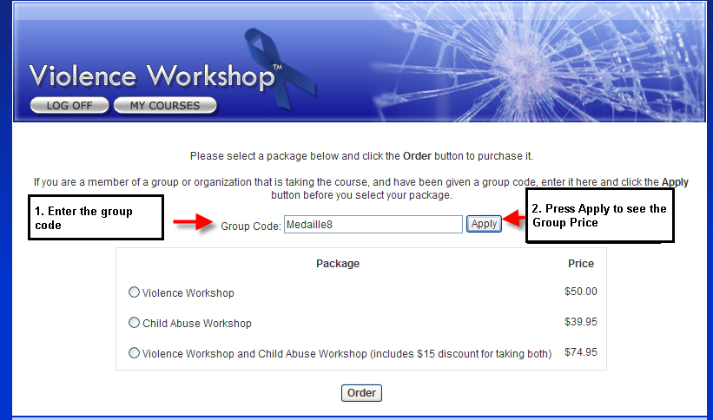

When you press Apply, you will see the discount and which package(s) it applies to.
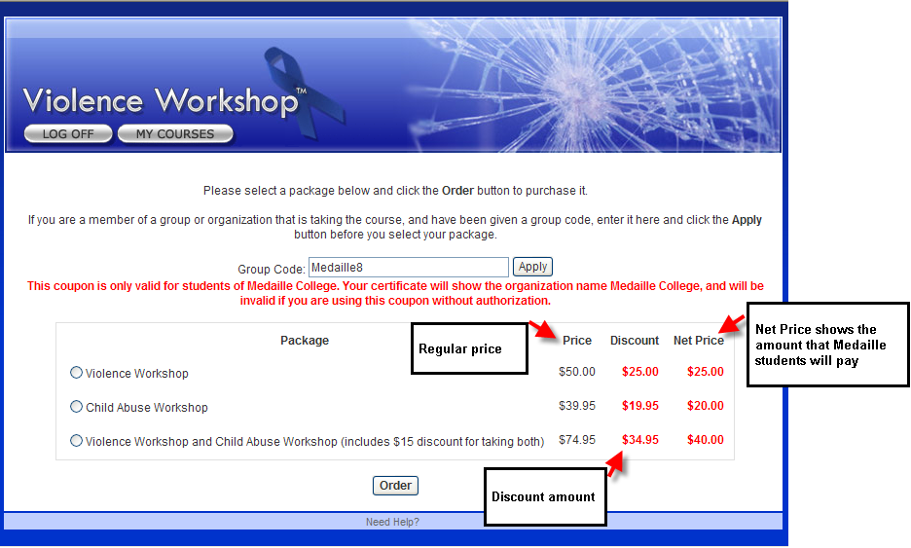

After seeing the price offered for that group, select the desired package.
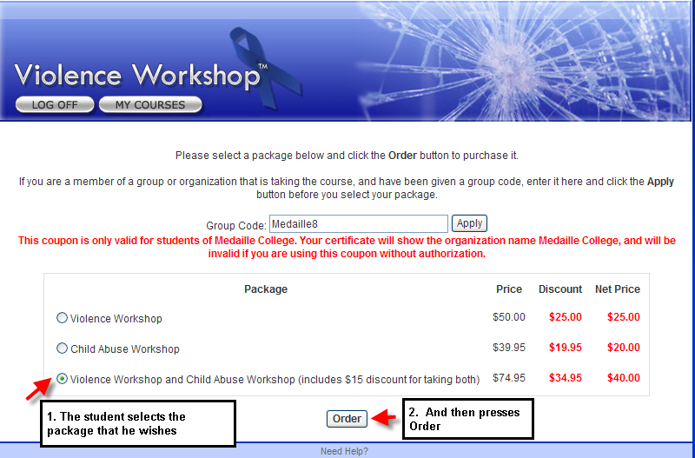

3) Pay When you press Order you will see the Payment screen. Choose a method of payment.
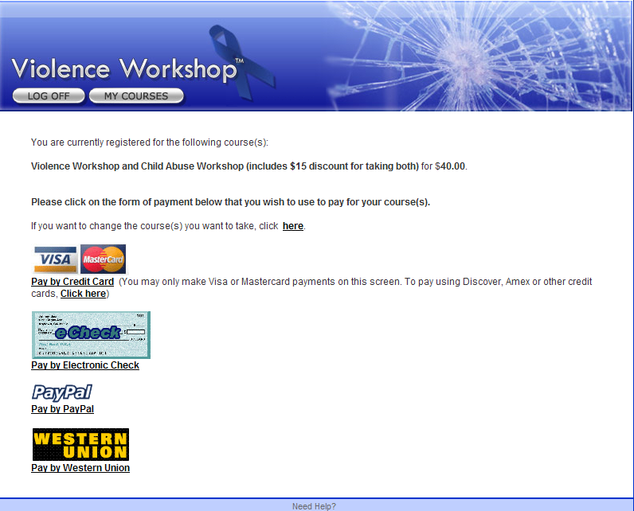

Take the course. After paying, you can start taking the course immediately or choose to start the course at a later date.
Print Certificate. Upon completion, print your own certificate or request that one be mailed to you. The Course Coordinator can also print the student’s certificate.

